Week 7 PDA evidence

|  |  |  |  |  |
| --- | --- | --- | --- | --- |
| **Week 7** | **Unit** | **Ref.** | **Evidence** | **Done** |
| A & D | A.D 5 | An Inheritance Diagram |  |
| I & T | I.T 1 | Take a screenshot of an example of encapsulation in a program. |  |
| I & T | I.T 2 | Take a screenshot of the use of Inheritance in a program. Take screenshots of:  *A Class  *A Class that inherits from the previous class  *An Object in the inherited class  *A Method that uses the information inherited from another class. |  |
| P | P 11 | Take a screenshot of one of your projects where you have worked alone and attach the Github link. |  |
| P | P 12 | Take screenshots or photos of your planning and the different stages of development to show changes. |  |

A.D 5

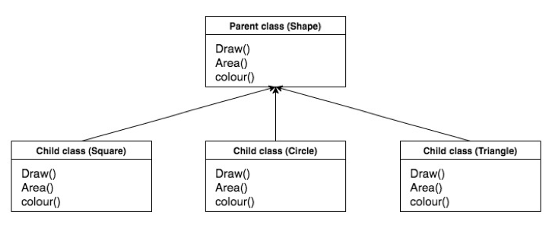

I.T 1

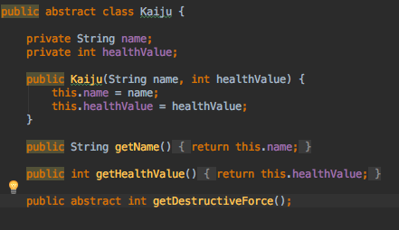

I.T 2



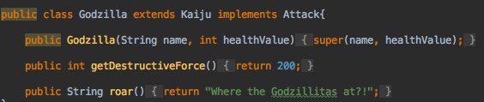

P 11

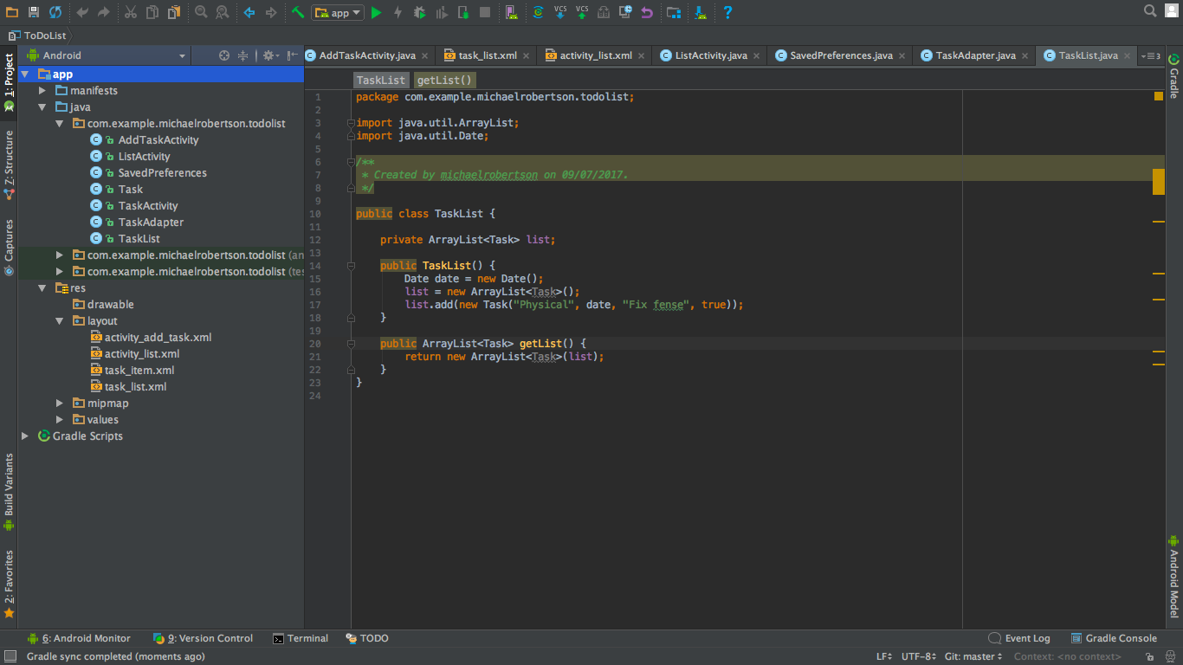

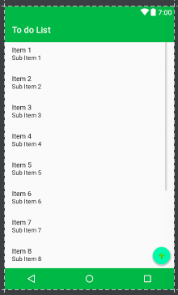

https://github.com/Mrober202/ToDoListProject

P 12

